Scoil Ghráinne CNS Newsletter

**December, 2016**

**Junior Infants** had a very exciting month in December. We performed our school play of Little Red Riding Hood and it was a great success! Thank you to all the Mums and Dads, Granny and Granddads and anyone else who came to see us. The Junior Infants are looking forward to the winter break and we would like to wish everyone a Happy Christmas and joyful new year.

**Senior Infants** have been busy preparing for our Winter Performance of Goldilocks and the Three Bears. We have loved learning to sing and dance, and loved performing on stage in front of our parents. We have all been learning about the cold winter season and hoping that we get to see snow this year. We talked about and looked at toys from long ago and compared them to toys from today. We thought the old toys looked like fun, but we preferred our modern toys. We searched for things that used electricity in our class and talked about things at home too. We then discussed how to be safe around electrical appliances.

**Croí** Ms Ryan's class have had lots of fun watching all of the Christmas performances, singing Christmas songs and doing Christmas art. Some of the children have been practicing the skill of Visualisation while reading, while others were working on answering "who" while reading "Golidlocks and the Three Bears". We had a lovely day on the 19th of December, when some of the parents came to visit us for a cup of coffee and some cake. Thanks to Doireann's mum for sending in all of the lovely books!

**Ms Egan's class** In Ms. Egan's Croí class, we have been reading the story *Say Goodnight to the Sleepy Animals.*We have been learning to ask and answer questions about the book. We have been using our PECS communication to play the animal board-game *'Where do I live?'* together. We have been learning about Christmas and we all worked together to create an enormous Christmas scene of Santa and his reindeer delivering presents to Croí.

**First Class** have been studying the topics of Christmas traditions and winter. We read stories from children who celebrate Christmas around the world and spoke about our own family traditions. We painted pictures of a winter wonderland and sang Christmas songs. We got to watch the senior infants rehearse for their Winter performance and we look forward to our performance in Spring.

**Second class** the boys and girls have been busy learning about 'Winter' and 'Christmas Around the World'. They have been very interested in learning the many ways that people throughout the world celebrate Christmas and how the traditions in Ireland, Poland, Mexico and Australia are so different. The boys and girls enjoyed sharing their personal experiences of Christmas outside Ireland. The children enjoyed watching the fantastic Christmas Concerts and were super impressed with how well they all did. The children have created some lovely Winter Art this term. 2nd Class would like to wish everyone a very Merry Christmas and a very Happy 2017!!

**LETTER FROM THE PRINCIPAL**

Dear Parents/Guardians,

Scoil Ghráinne hosted its annual Christmas raffle in the school on Tuesday the 13th of December. As I’m sure you can appreciate, a lot of organization is required for such an event and I would like to thank the PTA for all of their tireless work.

The raffle managed to raise a very impressive €4616.00 and a portion of this money will go towards the development of an outdoor classroom at the back of our ‘middle’ yard.

One of our PTA members Dana Marcinkevica, mother of Jaspreet in 1st class has developed a brand new Facebook page for Scoil Ghráinne. We hope to post upcoming events and school news on this page and we hope that it will be an additional way for the school to communicate with home. The new page can be accessed at <https://www.facebook.com/ScoilGhrainneCNS/> or you can simply search for Scoil Ghráinne CNS whilst on Facebook. Please like our page to receive notifications from the school. I would like to thank Dana for her hard work and the page looks great!

Well our first term has come to an end and I would like to take this opportunity to wish the whole Scoil Ghráinne community a restful and peaceful break over the Christmas holidays. We look forward to welcoming the children back to school on Monday the 9th of January for Term 2.

School closes for the Christmas break at 12 pm tomorrow and we will have a non-uniform day for all children.

Many thanks,

Ken Scully

**Dates to remember**

**Christmas Holidays**: School Closes @12.00 Thursday December 22nd and reopens Monday January 9th.

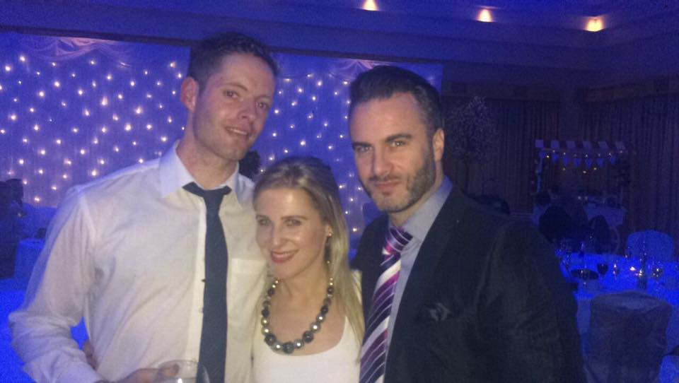

Mr. Quilty

Introducing Mr. Martin Quilty! Mr. Quilty has been with us here at Scoil Ghráinne for five years now. Mr. Quilty is a ‘true Dub’ and very proud of it. He attended St. Aidans' CBS in Whitehall secondary school and did a year studying Business in Trinity College before going to St. Patrick’s College of Education. He loves to read autobiographies, watch comedies (but he says they have to be actually funny). He likes to cook, but misses his Mammy’s cooking! He also does yoga and likes to keep fit. Mr. Quilty is sports mad and it’s no surprise as his first cousin is none other than famous Irish rugby player, Paul O'Connell. Mr. Quilty himself has never played rugby, as he is too injury prone! His main hobby is hurling. He actually played for Dublin Senior team for four years winning Leinster Title in 2013 - Dublins' first in 63 years! He is also the Vice-Captain of Dublin Under-21s that reached All-Ireland final 2011. Mr. Quilty is the current captain of ‘Na Fianna’ and trained the Under-15's and Under 16's last two years in the club. We are lucky to benefit from his amazing experience here at Scoil Ghráinne as he is involved with our G.A.A. He trains our teams and organises the 3rd/4th G.A.A. Blitzes. Mr. Quilty is well travelled. He’s been to Thailand, Vietnam, Chicago and New York. But he would like to do a lot more travel. Mr. Quilty loves a bit of ‘Good Craic’ and was head of our Social committee last year. He kept us all entertained with his witty emails! Mr. Quilty is one of our most versatile teachers and has taught in the junior and the senior end of the school. The children love his lessons at all ages. He is such a hard working, positive member of our staff and he keeps everyone smiling!

**Third class** have been learning all about the continent Antarctica and Tom Crean. They have been looking at symmetry and they even made symmetrical Christmas cards and snow-flakes. They practised very hard for their Winter Performances where they did such a brilliant job. Ms.O'Rourke, Mrs.McTigue, Ms. Kavanagh, Mrs Mulcahy and Ms Winters were so proud of them. All the boys and girls and teachers in third class would like to wish everyone a Happy Christmas and a lovely winter break.

**Fourth Class** were rehearsing and performing a selection of songs from A Muppets Christmas Carol. We have also been learning about Christmas traditions in other countries around the world including Australia, Norway and Germany.

**Fifth Class** have been learning all about the solar system. We created planet reports on planets such as Mars, Venus, Jupiter and Mercury. We also created papier mache planets which are now hanging wonderfully in our rooms! All the boys and girls were really interested in this topic and we've learned some really interesting fun facts. All the boys and girls are looking forward to the arrival of Santa this month so they're on their best behaviour:) From all of 5th class, we wish you and yours a very merry Christmas

**Sixth Class** have been learning a bit about Space. They were learning about the various star constellations in our night skies such as 'The Big Dipper', Orion and Taurus. In English, they were learning a poem by Robert Louis Stevenson called 'The Moon' - maybe they could recite it to you! In Gaeilge, they were learning about 'Eadaí' (clothes)

**it’s christmas!!!!!**



Christmas is very important here in Ireland as Christianity has traditionally been the largest religion. Although Christmas is a religious celebration for Christians, it is also a cultural celebration for billions of people all over the world. Different families choose to celebrate it in different ways. For many people, it is a chance to spend time with family and friends and show them that they care by exchanging gifts. Christmas is a time when we are reminded of the importance of being kind to one another. It is also a time when we can sing and dance and be in good spirits.