Scoil Ghráinne CNS Newsletter

**February, 2017**

**Junior Infants** The junior Infants have been learning all about clothes this month. We made some clothes out of play dough, we went on a materials hunt around the school and we completed a water proof experiment. We all agreed that making an umbrella out of tissue paper would not be a good idea! For Valentine's Day we made some lovely art. We hope you liked them! Soon the Junior Infants will be focusing on the outdoor play area. We are hoping the weather will improve so we can plant some seeds and maybe have some fun in the mud kitchen

**Senior Infants** In Seomra Oraiste, we have been reading Zog the dragon. We made our own dragon out of clay. We also talked about people who help us in the community. In Seomra Corcra we talked about Space and the Solar system. We planned what we would bring to the moon with us if we ever went! We talked about how we get day and night and experimented with how shadows are formed. In Seomra Dearg we have been talking about Fairytales. We read about Snow White and Little Red Riding Hood and discussed the connections and differences between them. We designed costumes for Fairytale characters using fabric. We have all been practising our forward roll during gymnastics!

**First Class** have been learning about the signs of Spring. We all made cards for Valentine’s Day and talked about complements. We are learning about 3D shapes in maths and we are talking about Toys from the past in history. We are also busy practicing for our Spring performance.

**Second class** The boys and girls in 2nd Class have been working very hard! The children looked at the theme of 'People Who Help Us'. The children identified the many people that help them including parents, teachers, family, friends, Mark and June. The children are very grateful for everything these people do for them! In English, the children wrote procedures on how to make milkshakes, toast and rice crispy buns. They successfully followed their own procedures and made some very tasty snacks. They have started to learn to write narratives. The children are continuing to enjoy Daily 5 where they are learning lots of new strategies to help with their reading including 'cross checking', 'inferring' and how to be voracious readers. In Maths, the children worked extremely hard learning to subtract by renaming. In Art, they studied Pointillism and the famous artist George Seurat.

**Third class**! In History This month we have been learning about clothes. We have looked at photographs of clothing from long ago and compared them to clothing styles today. We have also been designing and sewing clothes in Art.  In Maths we have been very busy learning about Division and Fractions. We have also started learning about the Famine in History and have been reading diary entries from people during that time. In PE we have been practising our hurling skills and are very excited for swimming lessons to start in March.

**LETTER FROM THE PRINCIPAL**

Dear Parents/Guardians,

I would like to thank all the parents who braved the bad weather to attend our ‘Internet Safety Talk’ on Tuesday the 28th of February. More than 60 parents attended the talk which was both informative and eye-opening. The importance of keeping our children safe on line is current and topical and it is something that we all need to be vigilant about.

You may have noticed that over the mid-term break that additional bike-racks and bollards were installed on our campus. This is thanks to the fundraising efforts of our Parent Teacher Association (PTA). We would ask all parents to ensure that all bikes are locked and we also ask that all parents, when using the set-down area, would take direction from Mark our caretaker and staff from the community centre to ensure that everyone arrives safely.

The Department of Education and Skills has given an InformationTechnology (I.T.) infrastructural grant to all schools that are more than 3 years old. Scoil Ghráinne received a substantial grant which has used this to install a wi-fi network in the school. This means that over the coming months we will be using I.T. as a means of enhancing the teaching and learning that takes place in our school. Initially this will begin as a pilot project in a selection of class groups, learning support and Croí and over time our aim is to provide I.T. enhanced learning throughout the school. We will keep you informed of all developments as they occur.

Many thanks,

Ken Scully

**Dates to remember**

**St patrick’s day:** School will be closed on Friday March 17th

*Special thanks to: Joshua Meade in 6th class who donated lots of lovely book sets.*

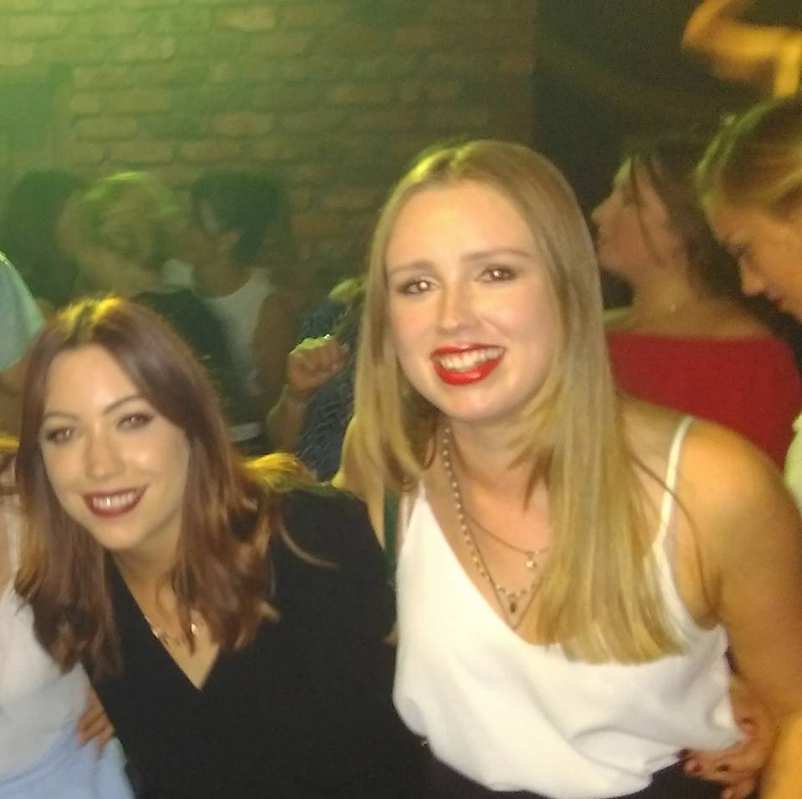

Ms. Duffy

Introducing Ms. Rosemary Duffy! Ms. Duffy is from Mayo and has been living in Dublin for four years. She is from a farming background. She loves eating her home-grown vegetables and feeding the baby lambs in spring! She has two sisters and one brother. My granny also lives at home in Mayo. Ms. Duffy is a very proud Mayo football supporter. Ms. Duffy received her B.Ed in Mary Immaculate College, Limerick. She has worked in schools in both Mayo and Dublin since and this is her third year working in Scoil Ghráinne. She taught senior infants for previous two years and is in learning support with 5th class now. Ms. Duffy’s favourite subjects to teach are English and Gaeilge. She runs the basketball club in school. She is very passionate about health and fitness and she loves getting out into the fresh air for a good run. She enjoys baking and making her own bread and muesli. Ms. Duffy has done karate and kickboxing since she was 8 years old and has a 2nd Dan black belt in Shotokan karate! She has won lots of trophies and medals at local and national level and even made it to a few world tournaments! Ms. Duffy really enjoys travelling and was lucky to get to travel with karate and kickboxing while growing up. She visited Iceland, Mexico, Thailand, Cambodia, England, Scotland, Germany, France, Spain, Croatia, Canada, USA. Her favourite place was Mexico. Ms. Duffy is a big team player, she loves taking part in school activities and is so helpful to other members of staff.

**Fourth Class** Boys and girls in Seomra Chonn (Mr. Condon's class) have been acting as Reading Buddies for the last few weeks. They have been inviting smaller boys and girls from Ms. Scott's Junior Infants up to fourth and reading with them. It's proven very successful for the pupils and both groups of students have been very enthusiastic about it.

**Fifth Class** This month 5th class have been learning all about World War 1, how it started and what the consequences were. The boys and girls were able to use lots of the information they learned last year about 1916 as both of these very significant events occurred at the same time. We also entered a poster competition the theme being 'Clean Water and Sanitation'. We learned all about the 17 Global Goals for Sustainable Development. If these Goals are completed, it would mean an end to extreme poverty, inequality and climate change by 2030.

**Sixth Class** This month in 6th class, the children have been learning about how Christianity had spread to Ireland long ago and how it has since changed. In art, they created Ogham Stones, which are ancient stones onto which people wrote messages. The early Irish people had their own alphabet made up of lines and notches. In maths, they have been learning about percentages and how to calculate the selling price of items - There may be a few great future accountants in 6th class!

**Croí**-**Ms Ryan's Class** worked very hard for their different teacher's while she was away, they did beautiful projects about space and lovely art work. They have also completed ‘Meet Me’ projects, and began collecting yogurt pots for planting seeds in after mid-term. **Ms Egan's class** have been reading The Gruffalo's Child. We traced maps of the story and we sequenced all the characters that the Gruffalo's Child meets. We're also learning vocabulary of clothes

**parents association news**

Scoil Ghrainne Parents' Association wishes to thank all of our pupils for supporting our wear ‘RED FOR VALENTINE'S’ non-uniform day. We raised **€812.80** for our school.  
If you are not already on our membership list, please give your contact details to the school secretary to get text notifications of our events and meetings.  Please get in touch with ***chairperson Emer Lynch on 087 6600701*** if you have any fundraising ideas.

