Scoil Ghráinne CNS Newsletter

**November, 2016**

**Junior Infants** have been busy reading The Very Hungry Caterpillar and Handa's Surprise. We painted butterflies and caterpillars, played in the cafe and some of us even made some play-dough! Next month we will be getting ready for our school show. We can't wait!

**Senior Infants** In Seomra Corcra, we read We're Going On A Bear Hunt. We have been observing the weather and recording our results. It got very cold this month! We enjoyed pretending we were in all the different scenes in our story and made collages of them in art. In Seomra Oráiste we read The Billy Goat's Gruff. We talked about Trolls and even got to make our very own Trolls out of clay. It was messy but fun! In PE we enjoyed having relay and sprint races and learning all about Athletics. In Seomra Dearg, we have been learning about space after reading about Baby Bear going to the moon in Whatever Next! We created our own colourful rockets from 2-D shapes we learned about.We also learned that day and night happens because the Earth spins around every day

**Croí** –

**Ms Ryan's Class** Seomra Glas have been working on many different things. One of the groups have been working on making predictions when reading stories, and writing character and scene descriptions. The other group worked at sequencing and answering questions about The Three Little Pigs, and answering "what do you like" questions. We have all been working very hard at completing our individual activities.

**Ms Egan's class** have been learning about the weather. We have been reading the story *Say Hello to the Snowy Animals*. We can name and sequence all the animal characters in order -- husky dog, polar bear, snowy owl, caribou, whale, seal, puffin and Arctic hare. In Art, we made fluffy polar bears and smiling husky dogs

**First Class** had an exciting November. Our topics this month were Dinosaurs and Space. We had great debates in class about the planets and we wondered if aliens were real and what colour dinosaurs might have been. We were doing gymnastics in PE and we all learned how to do a forward roll. In Gaeilge our topic was ‘Bia’ so we had a ‘comhra’ about what was in our ‘bosca lón’. In Art we made clay fossils and dinosaurs, we made beautiful Dinosaur World painting and made papier maché planets. We were learning about length in maths and had so much fun measuring our classroom, the yard, the corridor and each other!

**Second class** have been very busy learning about the theme of 'Under the Sea'. They have learned about the many animals and sea creatures that live under the sea, showing great interest in the octopus, dolphins and sea horses. The children wrote reports about their favourite sea creatures. The completed some beautiful pieces of Art work based on this theme.

**LETTER FROM THE PRINCIPAL**

Dear Parents/Guardians,

This year in Scoil Ghráinne we have decided to have two sets of performances. We will have both winter and spring performances.

**Junior Infants** will have their performance on Tuesday the 13th of December @ 12:40 pm (doors 12:30)

**Senior Infants** will have their performance on Wednesday the 14th of December @ 12:40 pm (doors 12:30 pm)

**3rd and 4th class** will have their performance on Thursday the 15th of December at 1:45 pm (doors 1:30 pm)

All other classes, 1st + 2nd, and 5th + 6th will have their performances the week before the Easter break.

There are many wonderful events taking place in the school over the coming weeks, please be sure to read the PTA section of this newsletter.

Recently one our Infant teachers Ms Cornyn has taken a teaching position in another school. This was the start of Ms Cornyn’s 7th year with us and we wish her all the best in her new school.

Also, Ms Dowling (a member of our SEN team) will be leaving us this coming Friday to take up a position in another school. This was the start of Ms Dowling’s 6th year in Scoil Ghráinne and we wish her every success and good fortune in her new school.

We have no doubt that both teachers will enrich their new schools in the same way that they have enriched ours.

Many thanks,

Ken Scully

**Dates to remember**

**Literacy Week:** Monday December 5th to Friday December 9th. The book fair will be on Wednesday 7th and Thursday 8th @1.30 – 3.30 in the school hall. Please come along and support us as it raises money for new books for our school.Dress up a character from a book on Thursday December 8th. If they choose not to take part, they must wear their uniform.

**Christmas Holidays**: School Closes @12.00 Thursday December 22nd and reopens Monday January 9th.

*A Special Thanks to Rian and Hannah’s Mammy who donated books and toys and to the parents in Mrs. O’Connor’s first class, who so generously donated to help out a family in their class. It showed a wonderful sense of community.*

**Third class** have been learning about life in Ancient Greece. We have been writing projects on the different food they ate, schools in Ancient Greece and the first Olympic Games. We even wrote our names using the Ancient Greek alphabet and designed Greek vases inspired by Athens and Sparta. In maths we are continuing to learn our multiplication tables and have started learning about 2D and 3D shapes. We have been practicing report writing and have written reports on our favourite animals. We have also been learning about the importance of internet safety.

**Fourth Class** have been looking at Thomas Edison in History and the changing nature of the light bulb. In Science we then created simple circuits using batteries and tinfoil.

**Fifth Class** have been focusing on report writing in English. We have been learning about our local area, Dublin 15, in Geography and History. The boys and girls have written and made wonderful projects as well as designed posters to welcome people to our local area. We are all proud of being from Dublin 15!

**Sixth Class** have been learning all about the United States, Native Americans and Brazil. One of the 6th classes has even been learning a song to name all 50 states in the USA. As well as that, 6th class have been doing a lot of work in Gaeilge to speak about 'siopadóireacht' (shopping). In art, the children have been creating 3D Totem Poles from papier maché.

**parents association news**

One book of tickets for our fantastic Christmas raffle will be sent home with each child this month.  Please return all your raffle tickets, whether sold or unsold, by 9th December.  You are under no obligation to buy the raffle tickets but it is very important that all unsold tickets are returned to the school. We have some fantastic prizes this year, including:

**1st prize** - Playstation 4,

**2nd prize** - Lady's Luxury Hamper worth €250.

Other prizes include two €75 vouchers for Grant's uniform shop! Sincere thanks to the members of the Parents' Association who gave up their free time to organise our brilliant raffle! You can make our raffle even better by donating spot prizes. There is a red box outside the school Secretary's office to collect raffle prizes donated by parents. We would be delighted to receive raffle prizes donated by businesses or companies that you may know. The school Secretary can issue an authorisation signed by the Principal to allow you collect prizes on behalf of the school. This is a great way to help raise vital funds for our school, which will be used to benefit **ALL** our children. Our very special "Reindeer Food" will be on sale in December, priced €2 each or 3 bags for €5.

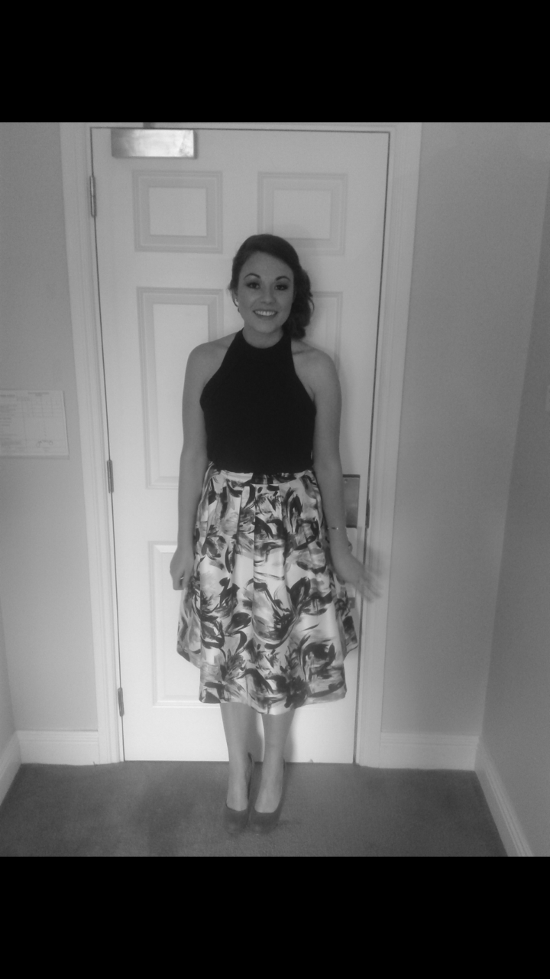

Ms. Scully

Introducing Ms. Kellie Scully! Ms. Scully is from Dublin. She is lucky to be the only girl in her house and is spoilt by her three brothers. This is Ms. Scully’s 3rd year working in Scoil Ghrainne. She loves teaching here and her favourite subjects to teach are Maths, History and PE. Ms. Scully achieved a Bachelor of Arts in English and Geography in St. Patrick's College, Drumcondra and then went to England, where she did a PGCE in Canterbury Christ Church University, Kent. After that, she taught in Luton, England for two years before coming home to Ireland. Lucky for us in Scoil Ghráinne! In her spare time she enjoys going to the gym (spinning and general keep fit classes). Ms. Scully is a real book worm, she loves reading. But her favourite thing to do is spend time with her family and friends and her dog, Jess who is a Golden Labrador. Ms. Scully helps run the girls' GAA team and this year she started Art classes for the boys and girls in 1st and 2nd Class. Ms. Scully is a bit of a dare devil. She did a bungee jump in Greece and a 15,000 feet sky dive for charity! Her birthday is on April Fools’ Day but she is no fool!! Ms. Scully is a fantastically creative, energetic teacher. The children are never in their seats for long in her class! She inspires other teachers to do active, fun lessons and she is an absolute pleasure to work with.