Scoil Ghráinne CNS Newsletter

**October, 2016**

**Junior Infants** The Junior Infants have been busy learning all about Autumn. We read Owl Babies and made some fun art pictures. We are really enjoying the assemblies on Fridays and are trying our very best to be organised. This week we are going on nature walks to look for different coloured leaves. We are looking forward to getting dressed up on Friday.

**Senior Infants** In Seomra Dearg we read ‘We're Going On A Bear Hunt’ and learned about different kinds of weather. In Seomra Corcra, we read ‘The Train Ride’ and enjoyed role-playing in our Train Station. In Seomra Oráiste, we read ‘The Little Red Hen’ and became farmers just like her. We planted cress seeds and watched them grow. All classes have been learning about Autumn and went on a Nature Walk to find signs of Autumn. We even painted our own colourful Autumn trees.

**Croí**   
**Ms Ryan's Class** have worked on lots of different topics this month. We learned about recycling and trees in Ireland in SESE, and we planted a Rowan and a Spruce tree in pots. Some of the children have been listening to the story of The Three Little Pigs, while the others were working on the story "Happy Halloween". We are learning all about Prediction Pam during our reading lessons, and have been practicing making predictions based on the texts that we have been reading. In **Ms Egan's class**, we have been learning all about 'Me and My Friends". We've also learned the words for Halloween characters. In Art, we created spooky ghosts and pumpkins, black bats and creepy spiders

**First Class** We have been studying the effects of Autumn this month. We collected and identified leaves and made beautiful autumn coloured leaf paintings. We learned about Oiche Shamhna in Gaeilge and decorated our classrooms with pumpkins we made for the old Irish tradition of Halloween.

**Second class**! This month, the boys and girls from 2nd Class have been very busy learning all about Autumn. They have really enjoyed learning about autumn weather and the many ways that deciduous trees change during the autumn months. The children have particularly enjoyed learning about hibernation and why many Irish animals hibernate during the winter months. They have created some beautiful pieces of Art work based on this theme. The 2nd Class children have also started to learn how to play the recorder. So far, they have really impressed their teachers. Keep an eye on the school blog for updates!

**Third class** We've been learning all about transport, the different types and how transport has developed over time. We also made our own toys cars and roads for them to drive on. We have also been learning all about data and made a bar chart showing our favourite TV shows. We are delighted to be learning to play the recorder!

**LETTER FROM THE PRINCIPAL**

Dear Parents/Guardians,

The first 8 weeks of school have gone by so quickly. I would like to thank all the children in the school for their hard work so far this year and all the incredible teachers and SNAs that we have on staff.

Last year we had a number of ‘You Can Do It’ assemblies throughout the year. This year, our behavior support team (Ms Prior, Ms Dowling and Ms Flanagan), have decided to have weekly assemblies for all the children every Friday to celebrate the many successes and events that take place in the school. This year all of our children are assigned to a particular ‘house’. We have the ‘Super Sharks’, the ‘Epic Elephants’ and the ‘Mighty Moose’. Children can still earn individual points for being organized, resilient, persistent, confident and for getting along, but this year they can earn points for their ‘house’ too. The children are really responding well to this latest development in YCDI.

As we are nearing the end of October we see that the days are becoming much cooler. We would urge all children to come to school with a warm jacket. Also around this time of year we feel that it is an ideal time to speak to your child around keeping safe around fires and fireworks, especially the older children who might be going out trick or treating alone.

I hope that you all have a restful week during the midterm break and we’re already looking forward to seeing the children return on Monday the 7th of November.

Many thanks,

Ken Scully

**Dates to remember**

**Non Uniform Day:** Friday October 28th. Bring in €2 for school fundraiser. (If you don’t wish to dress up, just wear normal clothes.)

**Midterm Break**: School Closes for midterm break Friday October 28th and re-opens Monday November 7th.

*A Special Thanks to Mrs. Dignam for her donation of library books and to Sinéad Jordan (Mr. Scully’s sister) for the donation of library books and the Lego set.*

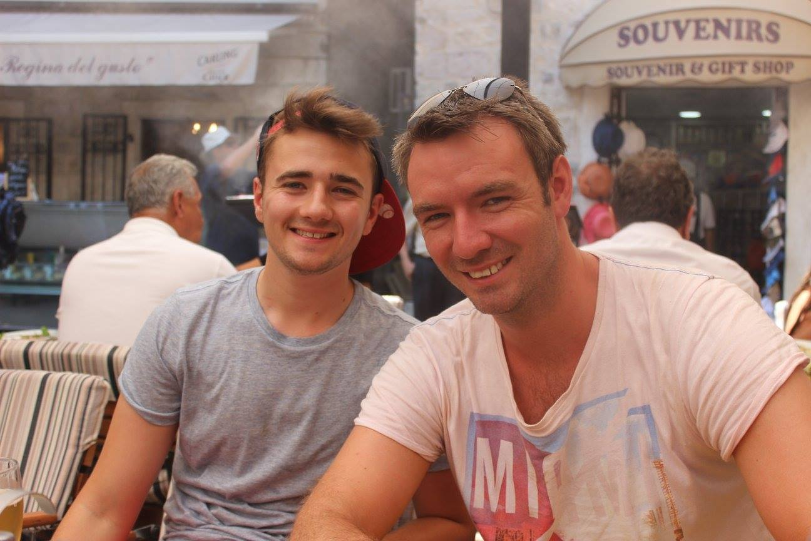

Mr. Murray

Introducing Mr. Ross Murray! This is Mr. Murray's third year in Scoil Ghráinne and he loves working here. Mr. Murray has a degree in Multimedia and loves graphic design, as can be seen from his colourful classroom. Before becoming a teacher Mr. Murray worked in a bank for a couple of years and was also was a professional actor, performing in The Helix Pantomime (Oh yes he did!) Mr. Murray loves drama and loves to wear a funny costume into school. He writes and directs pantomimes every year for his local musical society in Leixlip, where he is from. He has also written pantos for The Olympia Theatre in Dublin, starring Jedward! He hopes that he can write a show that Scoil Ghráinne will perform in the future. Mr. Murray loves to travel and has been to Australia, New Zealand, Thailand, Hong Kong, Alaska, California, New York, Bermuda and even Donegal! He spent 5 weeks cruising the Mediterranean last summer! Mr. Murray has been involved with soccer in Scoil Ghráinne and is a keen football player/fan but unfortunately he supports Aston Villa! He loves to cycle and has cycled from Kildare to Galway 3 times. Mr. Murray loves teaching in Senior Infants and they are singing and dancing at every opportunity. Mr. Murray is so enthusiastic with the children and we love to see his happy face around the school always with his trusty man-bag!

**Fourth Class** the last two weeks in class we've been looking at the festivals of Diwali and Halloween. In art fourth class have been looking at pointillism, and have created pictures of boats and Halloween pumpkins using the technique of joining dots to create images.

**Fifth Class** This month in 5th class we have been learning all about myths and legends. We studied Irish myths such as the 'Dulahan' and 'The Banshee'. We also studied mythical Greek charters such as 'Medusa'. In art we made scary 'Medusa' heads! In science we learned about the human body and how we breath and move. We also learned about the life cycle of the salmon.

**Sixth Class** have been doing some work around the theme of food. We have been looking at the Great Hunger that struck Ireland during the 1800's and its effects on the population of Ireland. We have been looking at poetry about Fish and Chips also. In science, we are investigating the packaging of foods to see the kinds of nutrients that are in our favourite foods

**parents association news**

Scoil Ghráinne Parents Association had a very busy October, organising the **photographs** for our **2017 class calendars**. A big thank you to the members of the Parents Association who helped the photographer coordinate the photos and made sure everything went smoothly. The calendars are on sale for a limited time, priced **€5**. The calendars make great presents for friends and relatives, especially those overseas. We are also very busy arranging our huge **Christmas raffle** and we have some amazing prizes to be won, with more being added every day. Christmas is a very busy time of year for the Parent's Association so we welcome any new members, as every pair of helping hands count! We would also be very grateful to any parents who could donate a prize themselves. There will be a red box outside the school secretary's office to collect raffle prizes donated by parents and these donations will be included in our raffle as spot prizes. On **October 28th** the school will be having a **special Halloween non-uniform day.** We ask each child to bring in **€2** and wear their favourite**costume** to school that day! We will be holding our **Annual General Meeting** in November. This is a great opportunity to meet the Parents Association and other parents for a cup of tea or coffee. If you are interested in joining the committee, please leave your contact details with our school secretary to get text notifications. The Parents' Association is passionate about improving facilities and learning experiences for **ALL** our pupils. Please contact Chairperson Emer Lynch on 087 6600701 if you know any businesses or companies who would be willing to donate prizes or sponsor events in the school, or if you have any fundraising ideas.