Scoil Ghráinne CNS Newsletter

**October 27, 2017**

**Junior Infants** have settled in so well this year! In September our topic was ‘Myself and My Family’ and the children brought in photos of their families. We read lots of stories. We especially liked Rainbow Fish, Elmer and Owl babies. We learnt lots of nursery rhymes and in maths we were looking at the number 1 and 2, capacity and Day and Night. We turned our play areas into a campsite and found leaves on our nature walks.

**Senior Infants** In Seomra Dearg we read We're Going On A Bear Hunt and created beautiful grass, river, mud, forest and snowstorm collages. In Seomra Corcra, we read The Train Ride and are enjoying our Daily 5 stations. In Seomra Oráiste, we read The Little Red Hen and became farmers just like her planting cress seeds. All classes have been learning about Autumn. We went on a Nature Walk to find signs of Autumn. We even painted our own colourful Autumn trees.

**Croí - Ms. Ryan**’s class have had a fun month exploring the theme of Our Body. We are going to continue this theme by learning about the senses. Happy Halloween to all! Have a safe and enjoyable mid-term break. **Ms. Egan’s class** have been learning three new Halloween songs-- 'Five Little Pumpkins', 'Five Creepy Spiders', and 'The Monsters Stomp About the House'. We have been having fun learning the names of Halloween characters and creating Halloween Art. In October, we learned facts about Autumn and explored real leaves, acorns, and conkers. We have been reading the story *Owl Babies.*

**First class** are learning about Diwali, Halloween celebrations and the human life cycle. Some of the children made bats for art and Rangoli mats for Diwali. In maths we have be learning to tell the time using half hour.

**Second class** have been learning Autumn and we went on nature walk where we collected many items. We also were learning how to write persuasively by engaging in talking debates on current topics and we even tried persuade Mr Scully to allow us to get a class pet. We learnt about Diwali, Eid, Dia de Meurtos and Halloween.

**Third class** have been learning all about transport and how cars and other vehicles have developed over time. We made our own racing cars and roads for them to drive on. We have also been conducting surveys on how the children in 3rd and 4th class travel to school and we are making bar charts to present our results.

**Fourth class** have learned loads of interesting facts about the human skeleton and all of our organs and we even made some very cool signature skeletons. We have been practising our GAA skills and learnt about Croke Park and the history of the GAA. All three classes have been working very hard on their science experiments in time for our Mini Scientist competition in November. We have been researching all sorts of topics and recording our findings and we are very excited to show them off. We have really enjoyed learning all about Diwali and Halloween this month

**LETTER FROM THE PRINCIPAL**

Dear Parents/Guardians,

I would like to extend a very warm welcome to all the new families and staff members that have joined Scoil Ghráinne this year. The school has grown steadily over the past 9 years and now in our 10th year of operation we have 687 children representing 62 different Nationalities and more than 20 religious backgrounds.

Work has begun on upgrading our school Library and I would like to thank my Dad, Johnny Scully, for helping to install the new laminate floor last week. We have great plans for the library and we are very excited about this project. We’ll keep you posted throughout the year. Please keep an eye on our school website for updates, class blogs and upcoming events. [www.scoilghrainnecns.ie](http://www.scoilghrainnecns.ie) or find us on Facebook.

As we are nearing the end of October we see that the days are becoming much cooler. We would urge all children to come to school with a warm jacket. Also around this time of year we feel that it is an ideal time to speak to your child around keeping safe around fires and fireworks, especially the older children who might be going out trick or treating alone.

I hope that you all have a restful week during the midterm break and we’re already looking forward to seeing the children return on Monday the 6th of November.

Many thanks,

Ken Scully

**Dates to remember**

Dress up Day – Friday 27th Oct €2 per child

Mid-term break: Fri 27th – Mon 6th Nov

**Fifth class** have all been very busy in 5th class this month learning all about different myths and legends. We have worked hard researching and creating projects on our favourite traditional and cultural myths and legends. We have been enjoying role-playing a Bialann in our classrooms. We worked very hard on drafting, redrafting and publishing our own pieces of recount writing. We participated in different maths week activities and a maths trail around the school. We have also been learning all about how we breathe in science, carrying out a pulse test in PE and identifying the joints and muscles which we have in our bodies

**Sixth class** have been busy writing persuasive essays, learning about tourism in Ireland and Fair Trade around the world, Bia, Mé Féin agus Oíche Shamhna through Gaeilge also. Sixth class designed fantastic self-portraits at the beginning of the school year along with many other art activities, some in celebration with Diwali last week.

**parents Association news**

Scoil Ghráinne Parents Association had a very busy October, organising the photographs for our 2017 class calendars.  A big thank you to the members of the Parents' Association who helped the photographer coordinate the photos and made sure everything went smoothly.  The calendars are on sale for a limited time, priced €5.00 each.  The calendars make great presents for grandparents, friends and relatives, especially those overseas. We are also very busy arranging our huge Winter Raffle and we have some amazing prizes to be won, with more being added every day.  A huge thanks to Ger Conroy Fitness at Junction 6, Dublin 15's newest and most state of the art gym, who have given us a month's membership for one lucky winner!  Very special thanks also to Jayden Quinn's mammy Liz who has obtained a €100 voucher from 53 Degrees North for us and more fabulous vouchers from Grant's Uniforms and Alan Dunne Photography. We would also be very grateful to any parents who could donate a prize themselves (such as unwanted presents, boxes of chocolates and biscuits).  In November, we will have a red box outside the school secretary's office to collect raffle prizes donated by parents, which will be included in our raffle as spot prizes. On October 27th the school will be having a special Dress-Up non-uniform day.  We ask each child to bring in €2.00 to school that day! The Parents' Association is passionate about improving facilities and learning experiences for ALL our pupils.  Our next project is to refurbish and upgrade our school library.  This is a huge project as we will need new flooring and seating as well as books. Please contact Chairperson Emer Lynch on 087 6600701 if you know any businesses or companies who would be willing to donate prizes or sponsor events in the school, or if you have any fundraising ideas. The Winter term is a very busy time of year for the Parents' Association so we welcome any new members.

**Celebration**

There are many important celebrations in our school. We do not expect all of our children to believe everything, but in Scoil Ghráinne we learn about different beliefs and learn to respect different beliefs so that we can have better understanding of each other.

On the 19th October, many of the children in the school celebrated a festival known as Diwali. It is celebrated by some Hindu and Sikh people. It is also known as the festival of lights. There are many ways of celebrating it. Some of the children in our school made Rangoli patterns and other created oil lamps called Diyas.

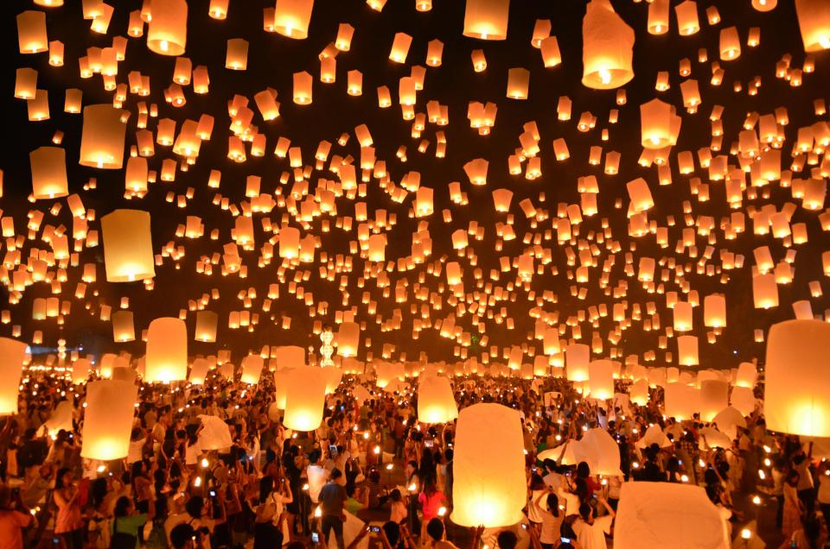

This week we will be celebrating Halloween. Halloween is an old Irish celtic festival which originated from 'Samhan'. It is also called 'All Hallows Eve'. In some countries it is a very serious celebration. In Ireland the tradition has developed over the years. Many traditions such as carving pumpkins has come from America because in Ireland turnips were once used as lanterns. Dressing up is now a tradition associated with Halloween

