ASHRAF SIDDIQUI
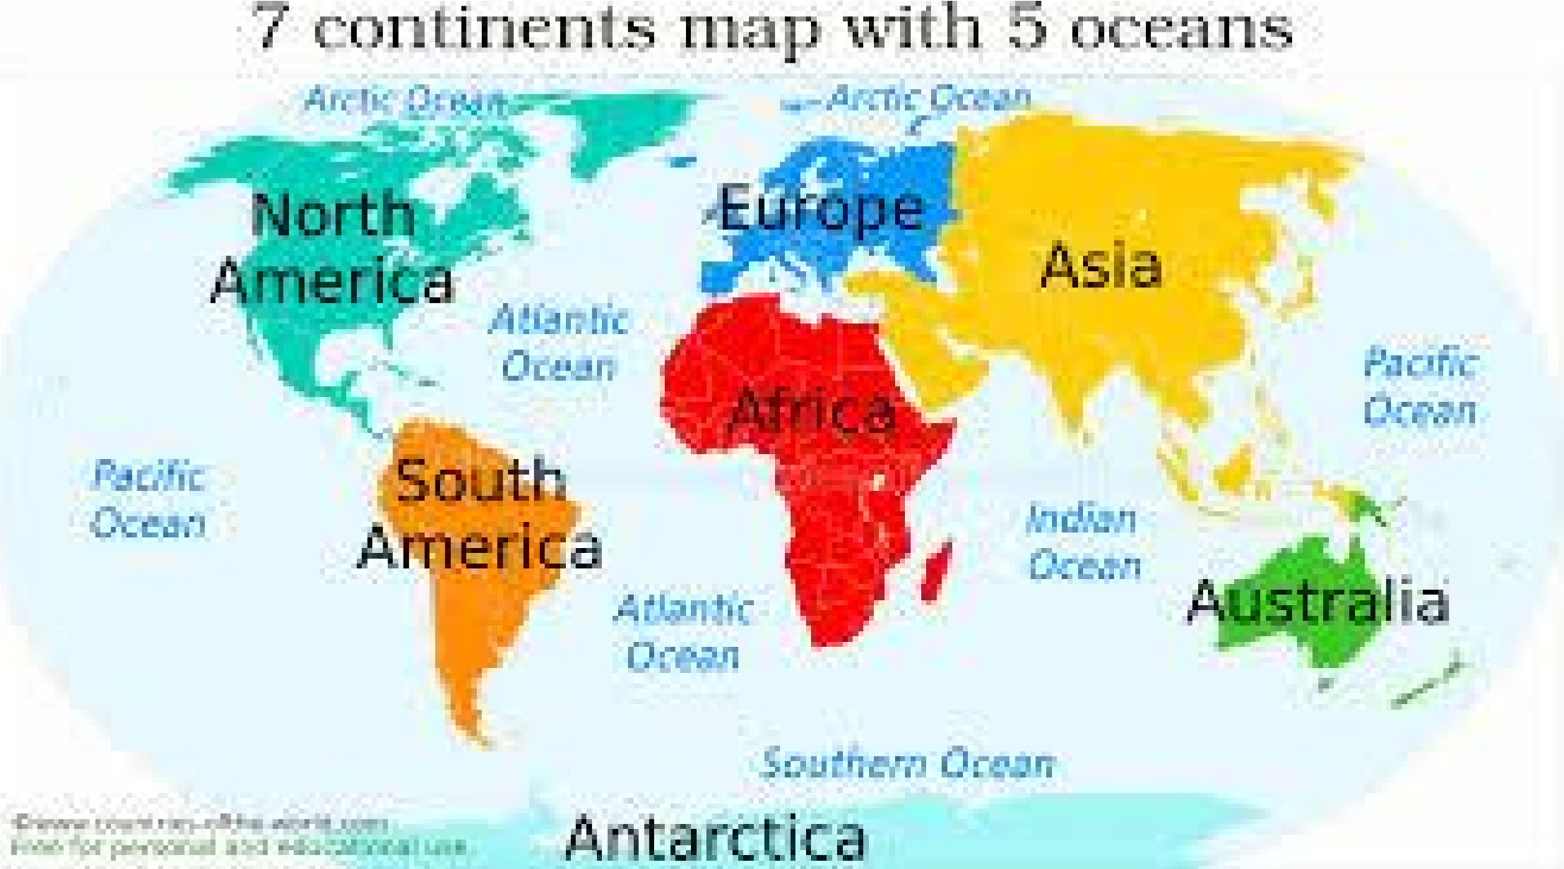
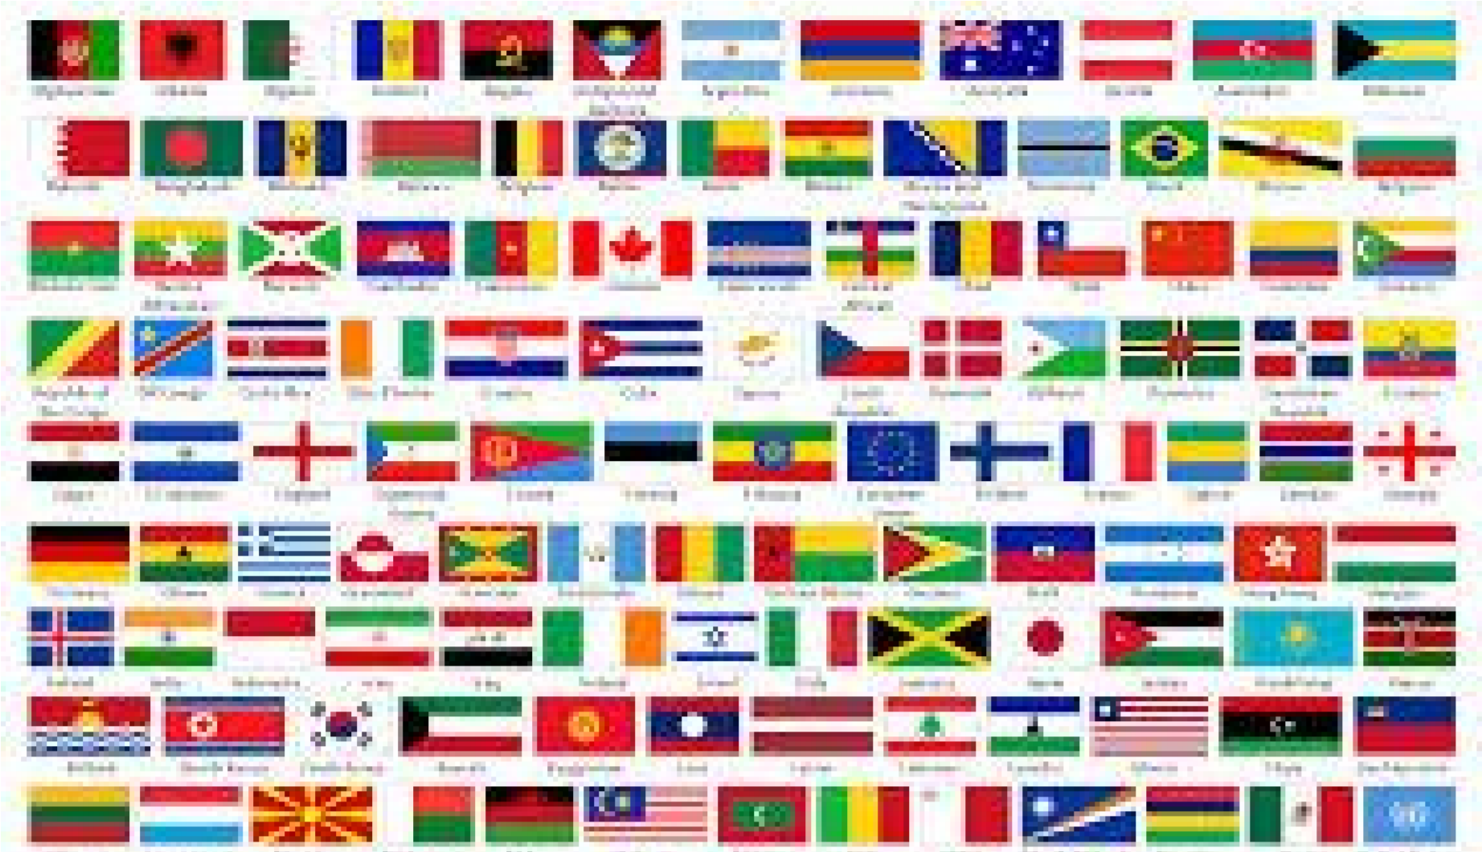
7
continents
- There are lots of countries in Asia.
These are some of the countries in Asia; China, Japan and India.
Asia is the Earth's largest and most populous continent, located primarily in the eastern and northern hemispheres.
It also have the highest mountain it is called Mount Everest.
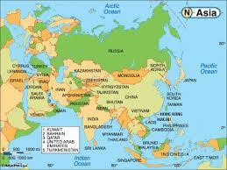
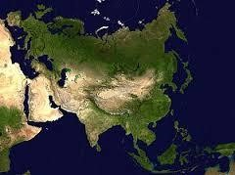
- Africa is famous for diamonds and chocolate.
And it also have the largest desert called the Sahara and it has the biggest river called the river Nile. Africa is the world's second-largest and second-most populous continent. At about 30.2 million km² including adjacent islands, it covers six percent of
Earth's total surface area.

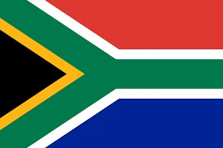
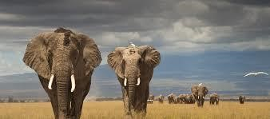
3 .Australia is famous for kangaroos. Australia is the biggest island in the world. Australia is surrounded by the Indian and Pacific oceans.
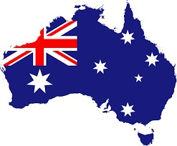
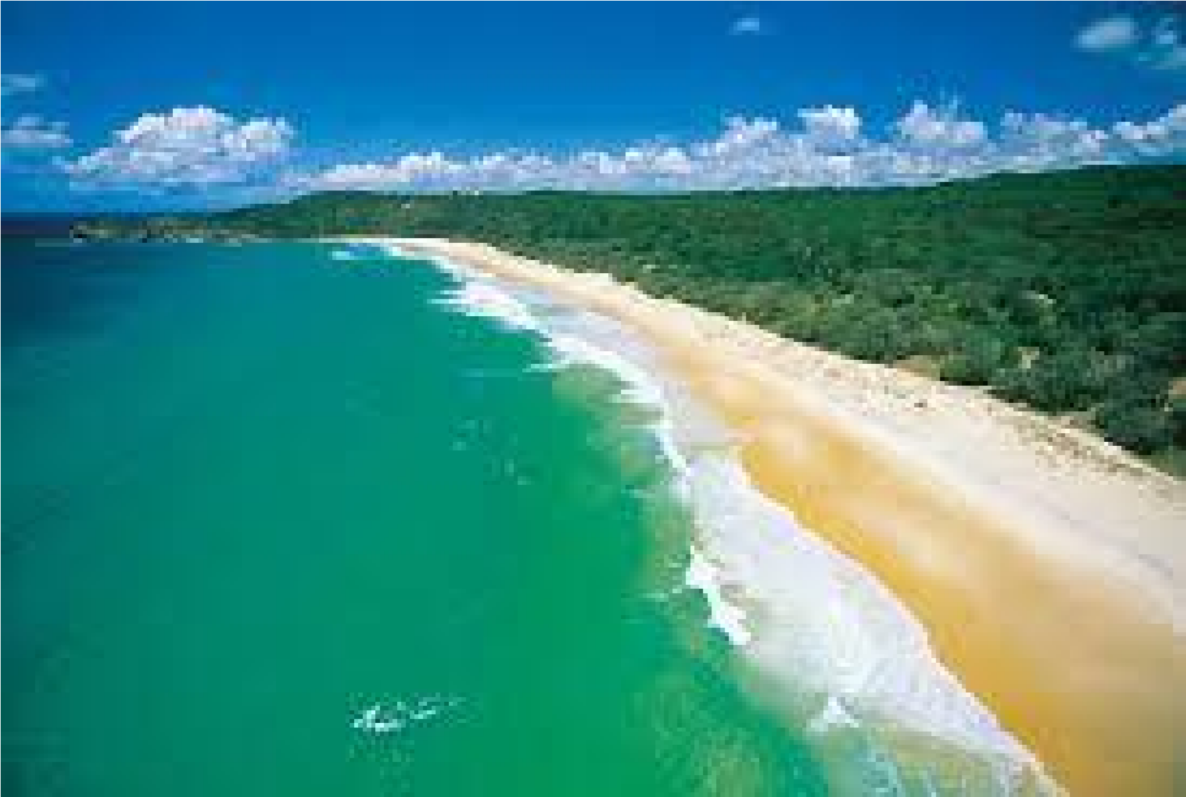
It has many major cities such as Sydney, Brisbane, Melbourne, Perth and Adelaide, but its capital, Canberra, is inland and nicknamed the "Bush Capital." The country is known for its Sydney Opera House, Great Barrier Reef, the vast Outback (interior desert wilderness) and unique animal species including kangaroos and duck-billed platypuses.

4. South America is home to the largest snake in the world. It also produces lots of coffee. It has the largest river called the Amazon River. Other famous things found in South America include Salt Lake, volcanoes and waterfalls.
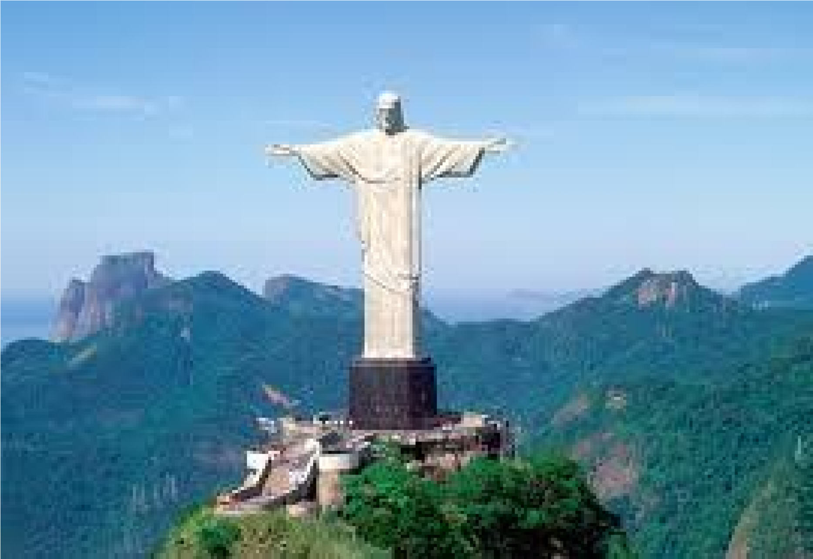
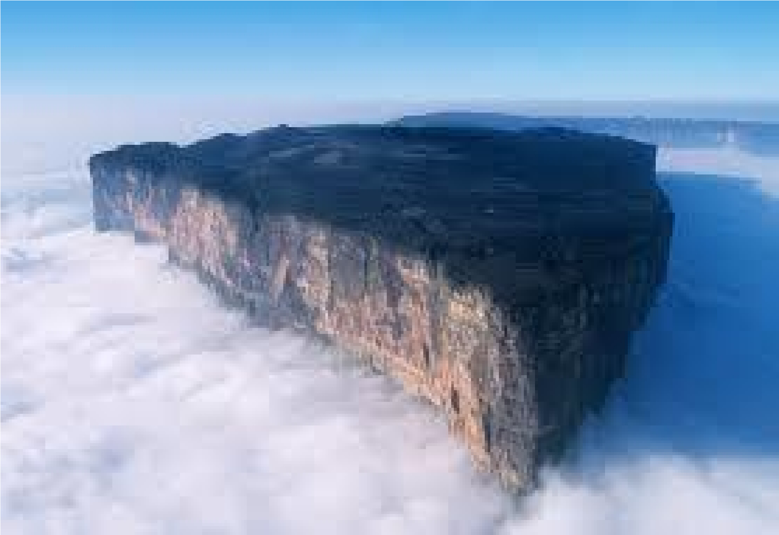
5. 98 percent of Antarctica is covered in snow.
It is called the frozen continent. It is the world’s coldest, widest, driest and highest continent in the world. Some people call it the ‘cold dessert’. There are no houses or villages on Antarctica. Some people visit Antarctica to help animals.
Antarctica, the southernmost continent and site of the South Pole, is a virtually uninhabited. The peninsula’s isolated terrain also shelters rich wildlife, including many penguins.
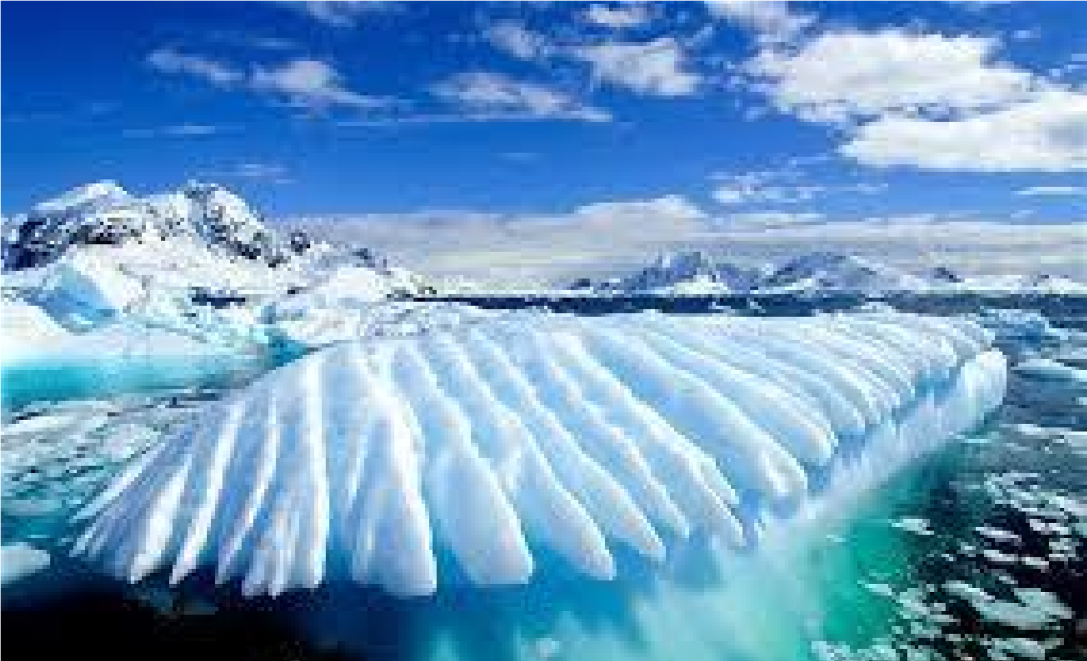
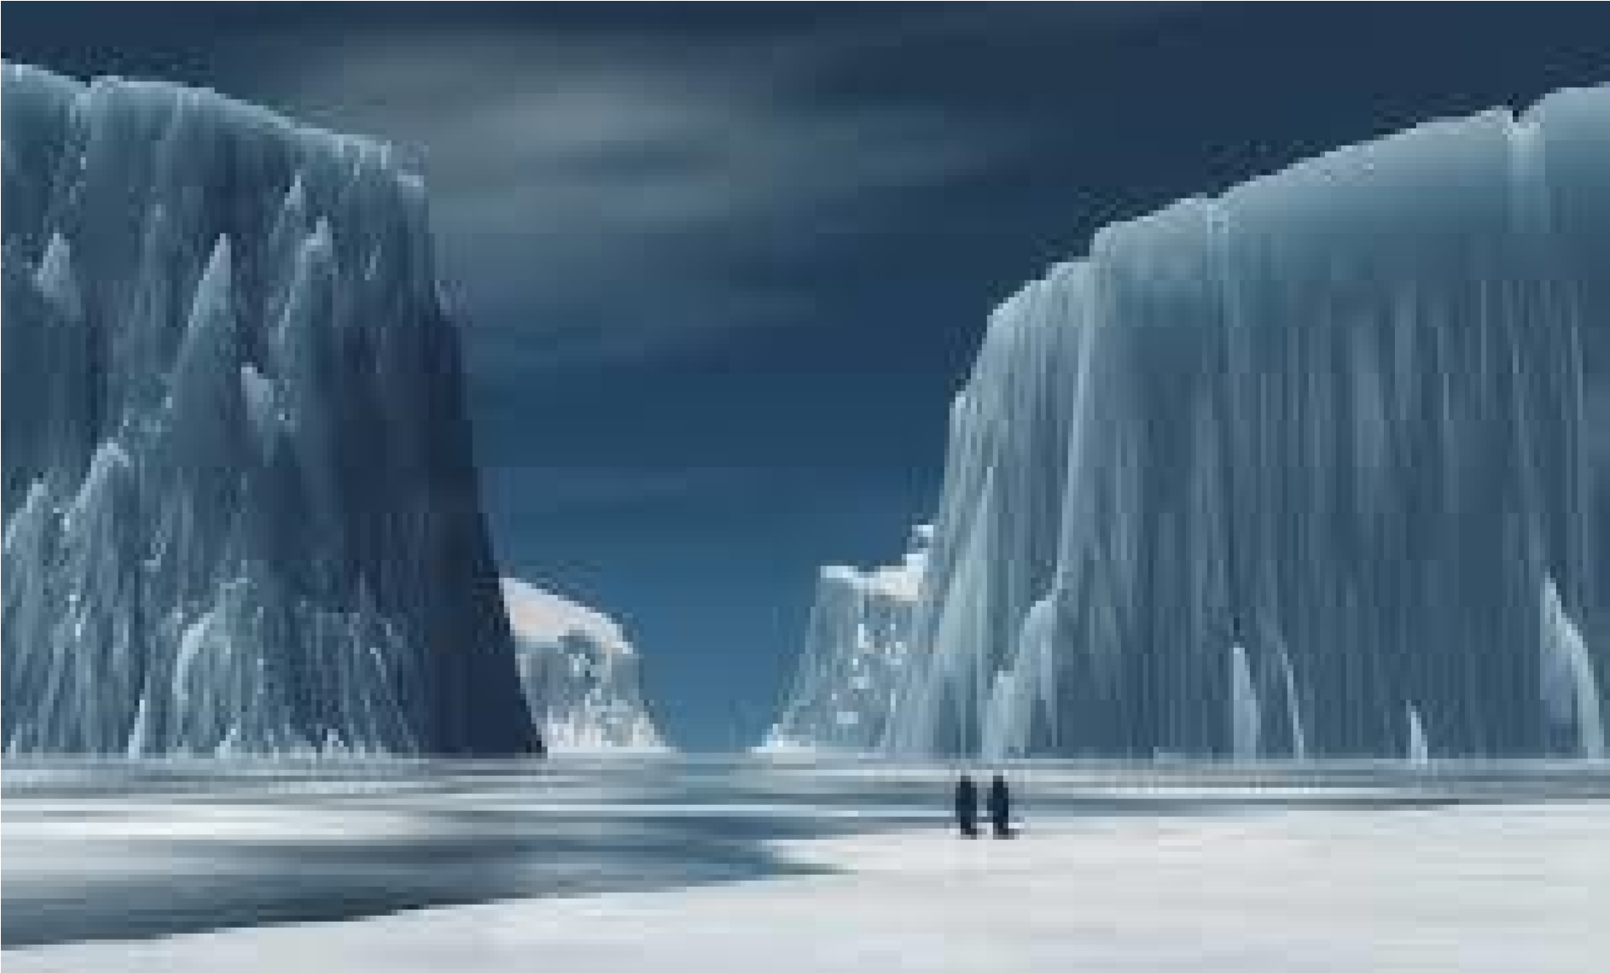
:
6. Europe it is the world's smallest continent in the world.
It has a city called Vatican city.
Europe is bordered by the Arctic Ocean to the north, the Atlantic Ocean to the west, and the Mediterranean Sea to the south.

Last continent is North America. It has lots of companies like Facebook, Apple and Google.
Some people called it the ‘new world’ because it was founded late.
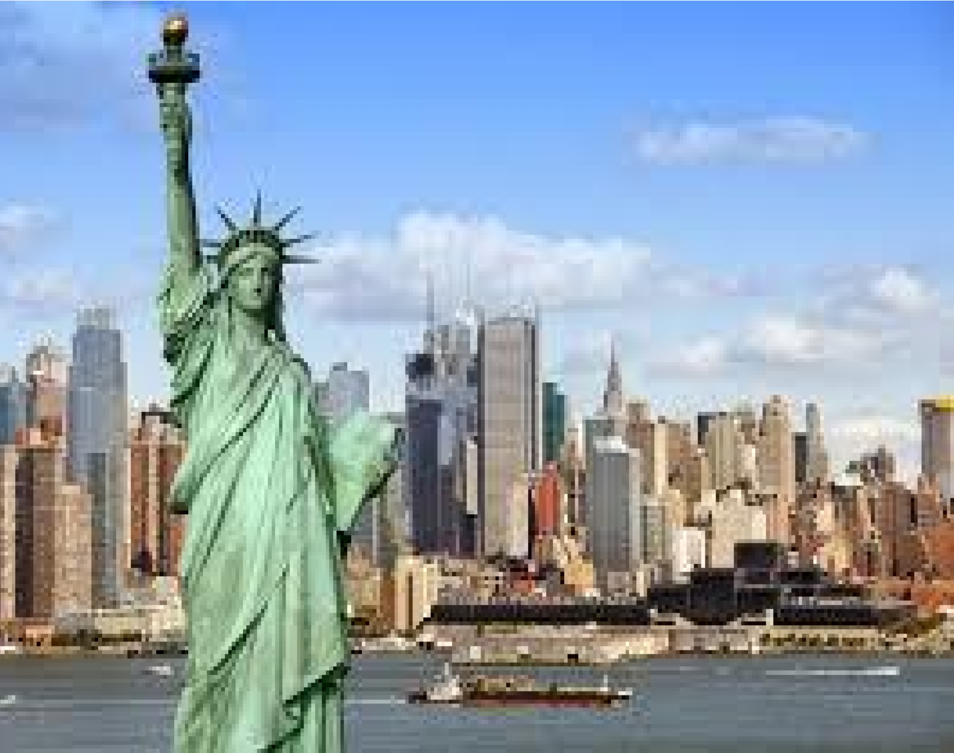
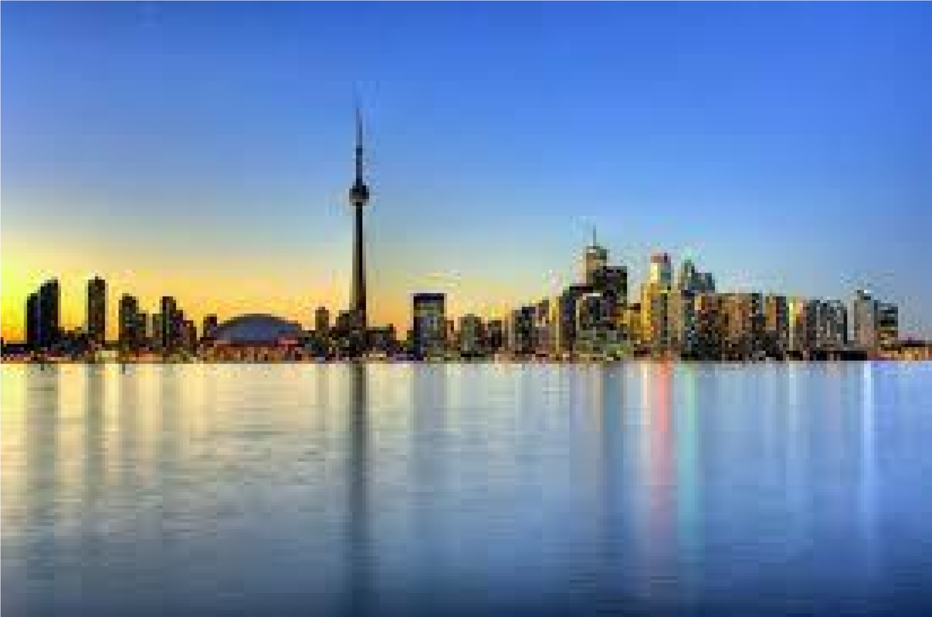
North America is a continent entirely within the Northern Hemisphere and almost all within the Western Hemisphere. It can also be considered a northern subcontinent of the Americas.
Area
:
24,709,000
km²
Population
:
528.7
million
(2008)
The end
Thank you for reading

