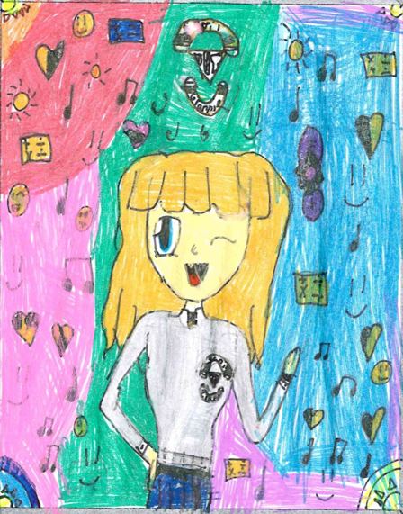

Thursday the 4th of April in the Community Centre hall. Doors open at 6:30 pm. Show starts at 7 pm.

Tickets €10 – available from school office

Poster designed by Sabirin Yusuf – Ms Kelly’s 3rd class

**Scoil Ghráinne proudly presents**

**‘Gráinne – This is Us’**